**LINEAR REGRESSION**

* Linear regression is a linear model that represents the linear representation between the input value (X) and output value (Y).
* It is used to predict the model with output value (Y) from the given input value(X)
* The above relationship between the input values (X) and output value(Y) can be expressed in the form of: **Y=a+bX, where a is the intercept and b is the slope of the line.**
* In the above equation a and b are called coefficients. Linear regression learning model estimates the value of the coefficients from the available dataset.
* In **simple linear regression**, there will be a single input value.
* In **multiple linear regressions,** there will be multiple input values.

**Linear regression learning model:**

* Estimates the value of the coefficients used in the equation
* The following are four techniques used for coefficient estimation:
  + Simple Linear regression
  + Ordinary Least Square method
  + Gradient Descent
  + Regularization
* Among the four techniques, **Ordinary Least square method** is most commonly used in estimation of coefficient values of the equation**.**

**Ordinary Least square estimation method:**

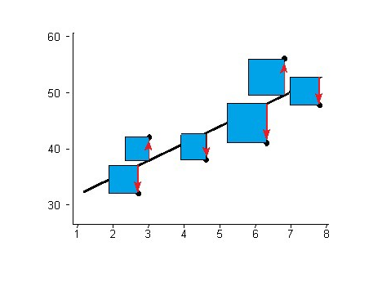

* From the above figure, we can understand that a line is plotted using linear regression equation, where the black dots indicate the data points.(observed)
* This model estimates the sum of vertical distance between the data points and the points on the line (predicted), which is indicated as a blue square.
* The points having the minimal distance are taken in consideration for calculating the coefficients.
* **Hence least square method is used to estimate the coefficient of the equation, where there is minimum distance between the sum of the squared errors between observed and predicted data points.**

**Example of linear regression:**

Let us consider that we need to calculate the weight of the person (Y) from the given height values (X).

Weight(Y) = a+bX

Where X is the height value and a, b are the coefficients of the equation which can be calculated from the ordinary least square estimation. Let us

Assume a=0.1 and b=0.05, and height value as 182,

Weight Y = 0.1 *+0.05*182) = 91.1

Likewise we can apply different height values and apply to our equation to get desired weight value and create a line as below.

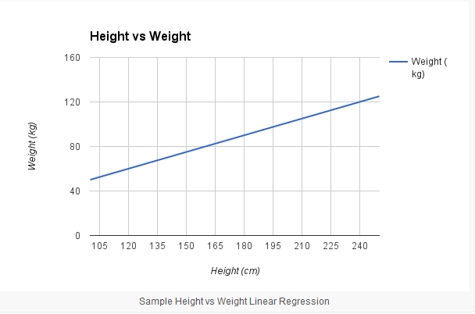

**Advantages of Linear Regression:**

* Represents a linear relationship between independent and dependent variable and hence shows optimal results.

**Drawbacks of Linear Regression:**

* Cannot show optimal results for non-linear relationship.
* Predicts only numerical data